**Storage Accounts**

1. If we are connecting to windows we will use RDP in the same way if we are connecting to storage explorer we will use Microsoft azure storage explorer.

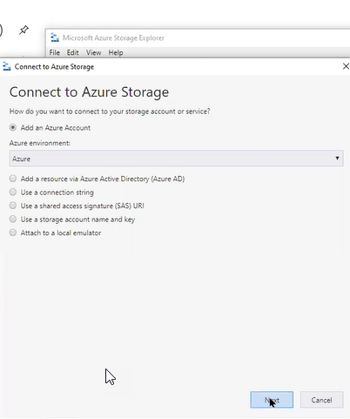

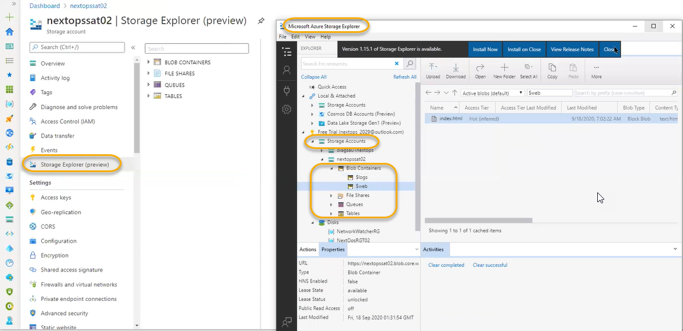

We can access through mobile browser so that we can upload it any where

Data transfer we can do it from command line those we are not comfortable with this we can do it from Microsoft azure storage explorer.

1. TLS - Transport layer security communication web based through https. How the web application is giving the security
2. We need to update the browsers so that we can see the latest version of TLS. Client and server side will be there for security compatibility
3. For internet explorer 11 will support the version 1.2
4. Whereas for 7 we have version of 1.1.TLS is Protocol to connect web server and web client.

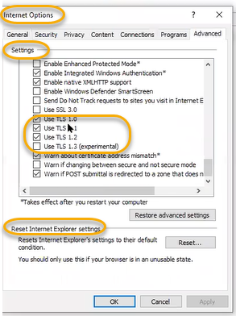

1. 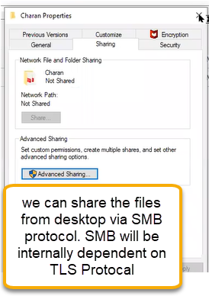
2. Currently TLS 1.2 version is running
3. Blobs service: in the container we cannot delete the logs where as $web we can delete it

If you want to organize the data we can use containers. Logical objects, Folder structure. We will create the container inside that we will create the blobs

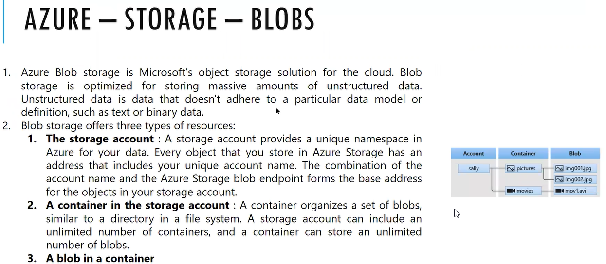

1. Initially storage is used for to store the files in the VM
2. With in the storage account, they are defined different types of storage
3. Within the storage account > Container (logical folder) > Blobs(different types of data, like huge amount of data,
4. We can store VM C drive file of 128 GB or we can save 1 kb file

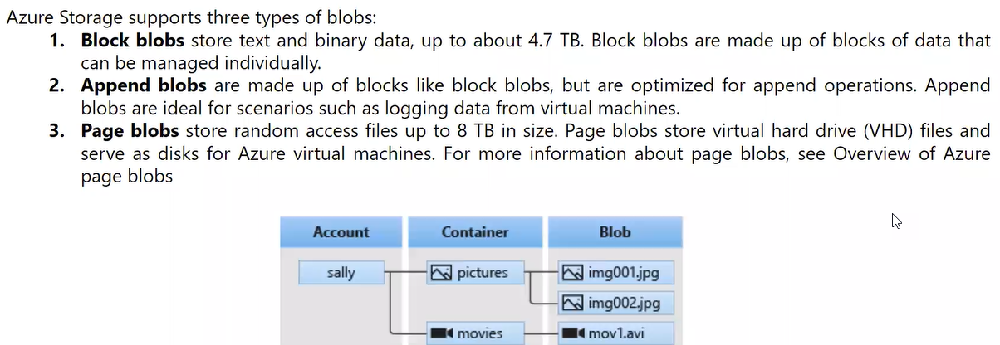

1. Block Blob: can store image, videos, pdf, disk file , word document. 4.7 TB
2. Anything below 4.7 TB is called Blob blocks
3. Append Blocks:
4. 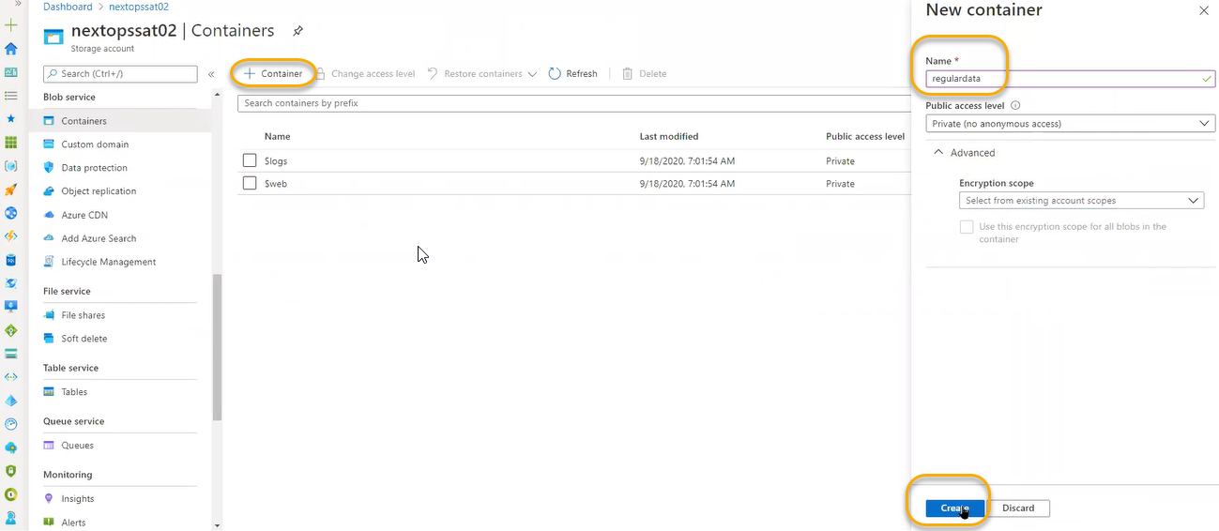
5. 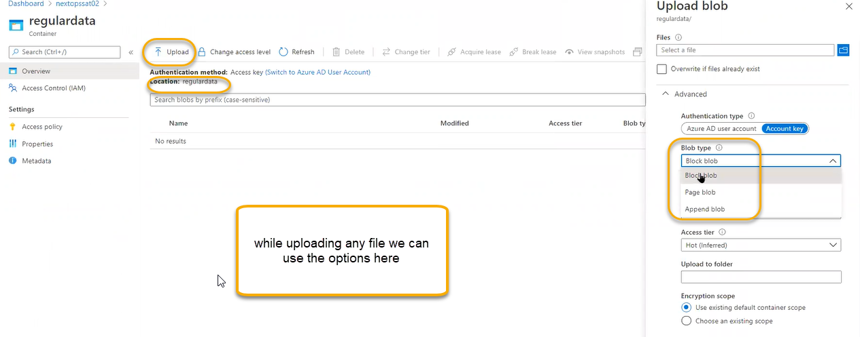
6. 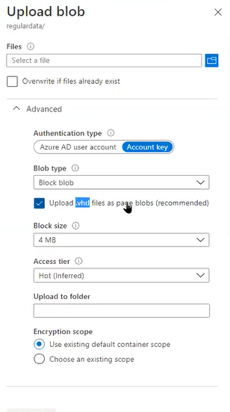upload to folder we can place the data in
7. If you are uploading the virtual machines disk files it will automatically treating as page blob

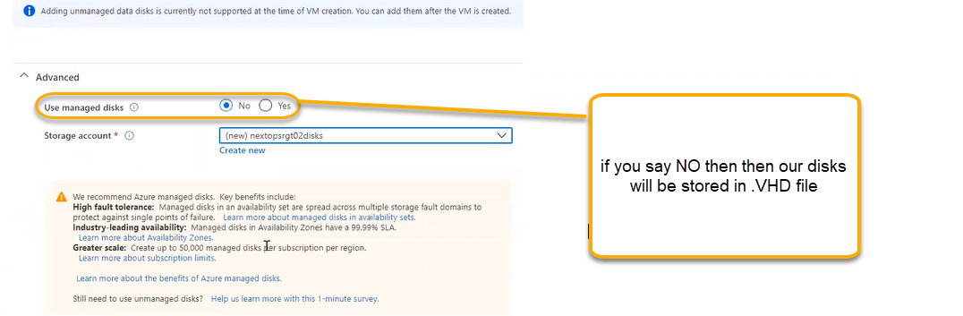Which means It is stored in storage accounts

1. Page blob: it is used to store 8 TB and it is stored in VHD files
2. If you create the VM and if we create the storage account as unmanaged disk for VMs we can give maximum storage is 8TB. That is called storage account limitation
3. Why we are not supposed to use the storage accounts for VM provision why we need to use managed disks is we do not have any overhead of storage account. If you store VM in storage account, then max size is 8 TB. And if you use managed disk, we can use 32 TB for VM
4. Append Blobs:we have created the static web container in the container we see the logs related to web site. Log file is continuous updated data if we do any small operation then the log files have been updated
5. In a storage account there is number of VHD files limitation. If we create the storage account, we can use only minimum number of VMS. Only 50,000 disks will be created in one storage account. If you need extra files, then we need to create the extra storage
6. If we use managed disks, then we don’t have limitation for managed disks we can create the availability sets also. For unmanaged disks availability set is not applicable.

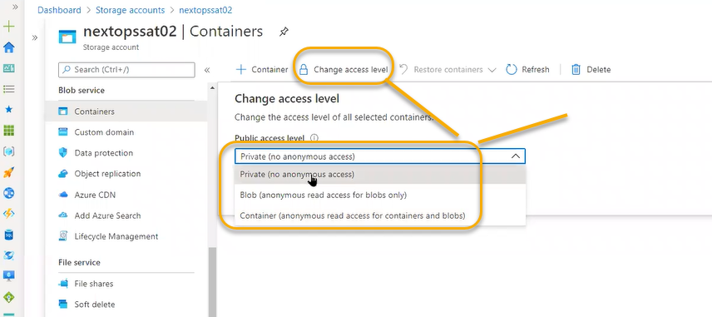

1. If you enable data protection, then can see the option as Restore containers as shown in the above screenshot.
2. Append Blob maximum Block size is 4MB and appended blob max default is 4 MB and block blob max size is 100 MB
3. If you install the drive for the very first time, then we need to format first file system will be created (To organize the files and folders). In windows we call it as NTFS and in the Linux we will ext3

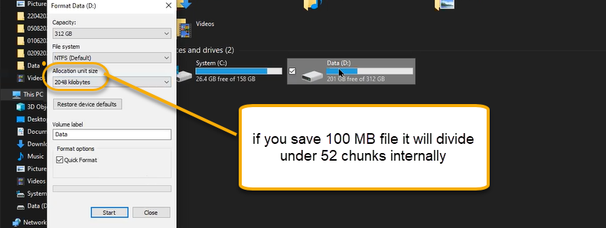

1. For database applications we need to support maximum data because of high intense of read and write operations as well as for Mail server, SAP server Blob size will be more instead of retrieving 2MB we can retrieve 100 MB
2. One file for how many pieces it should be in the file system the Blob size will be defined
3. Access tier: Hot: Frequently access the data cool: randomly access data and Archive means once in a year we will access the data

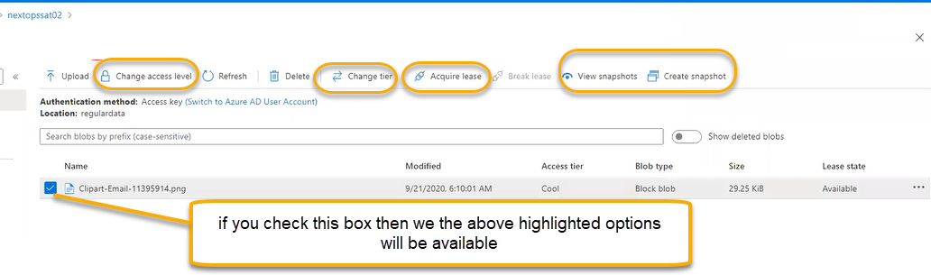

1. Acquire Lease: if you are doing data center maintenance and in the selected file, we are doing some operation and if you click on the lease then the control will be always present in our hands
2. And if you click on the break lease then the file will be accessible to some one

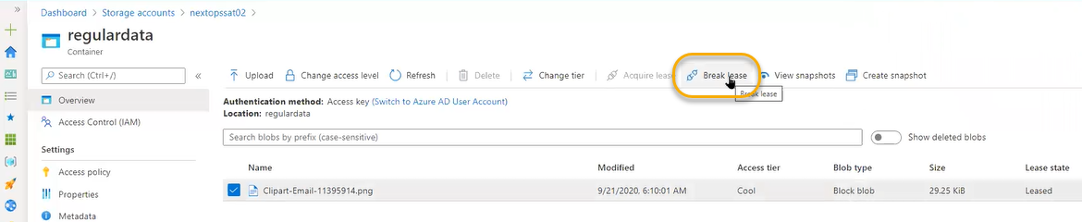

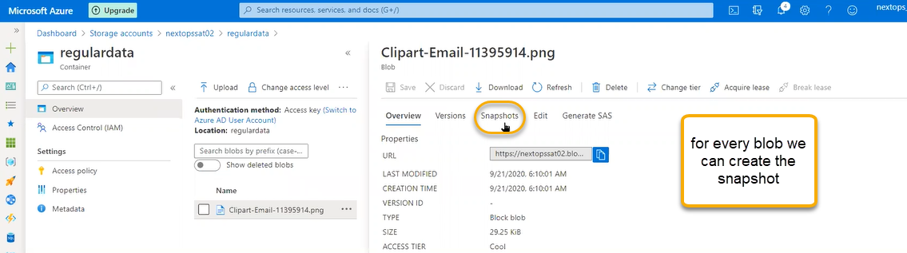

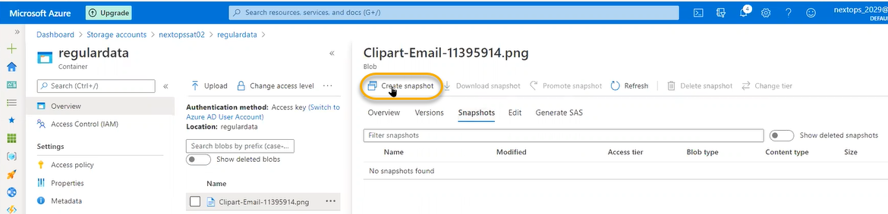

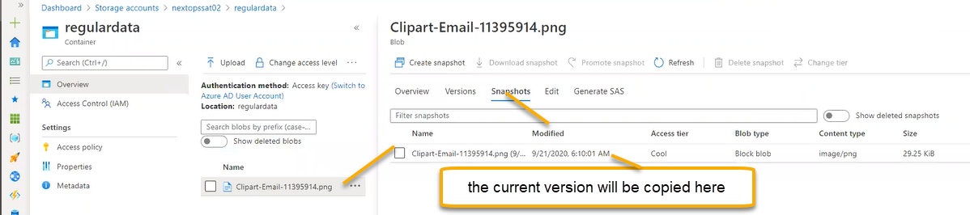

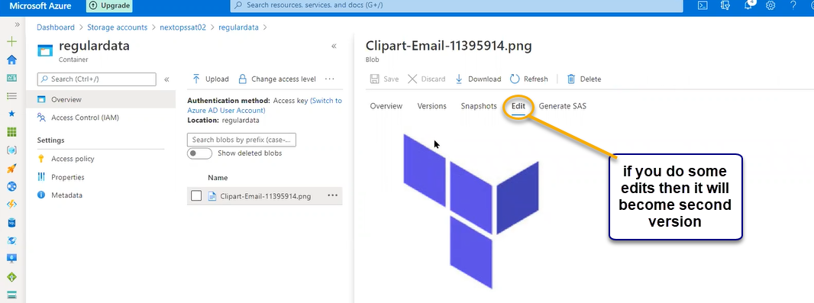

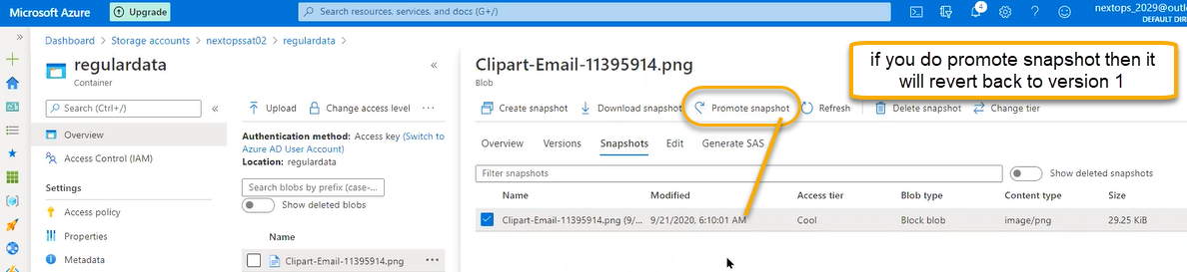

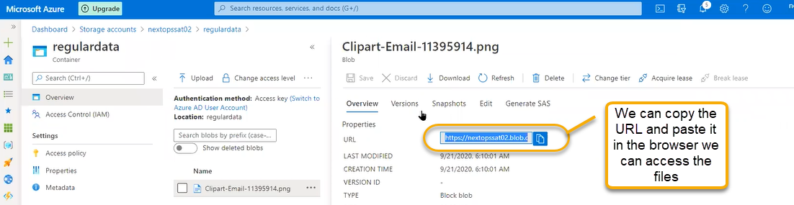

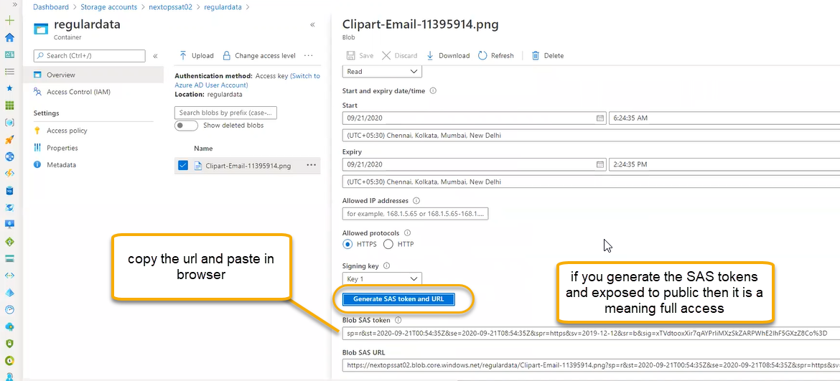

Data protection :

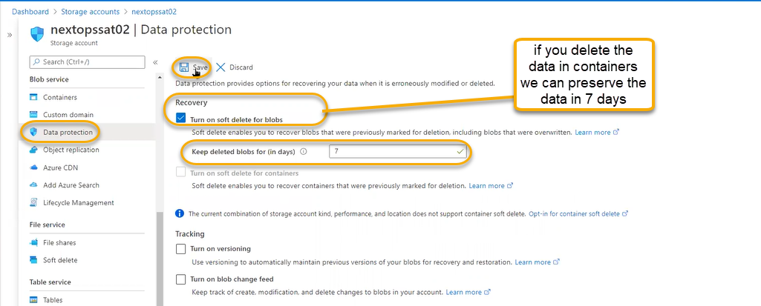

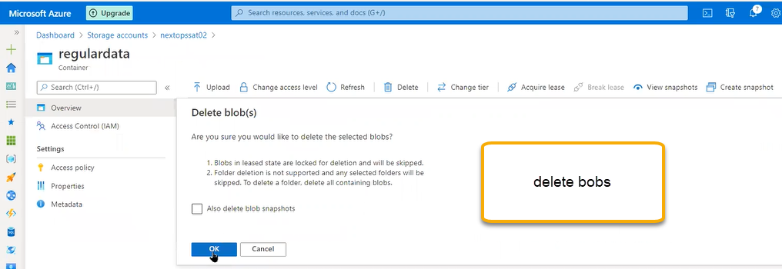

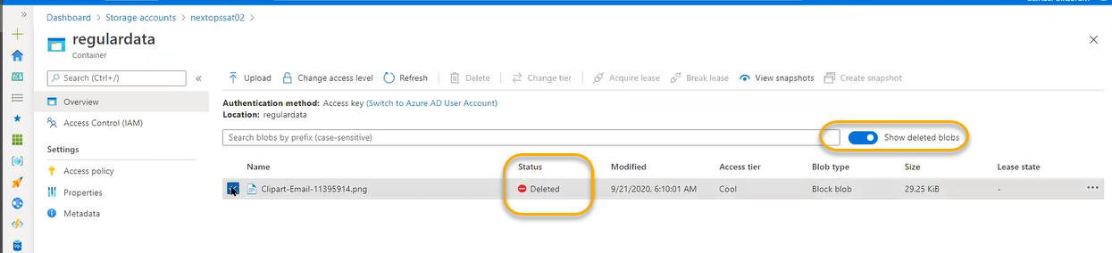

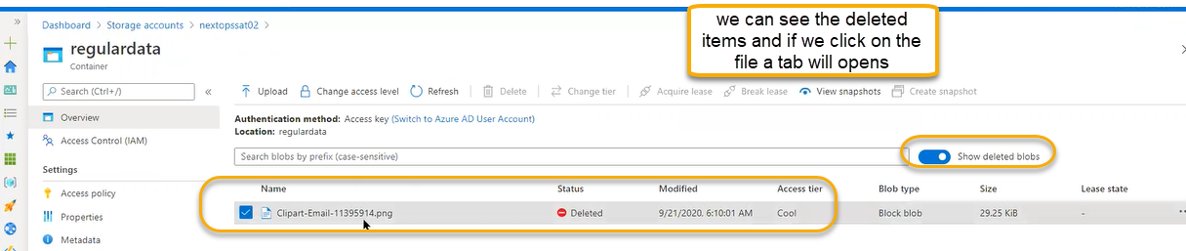

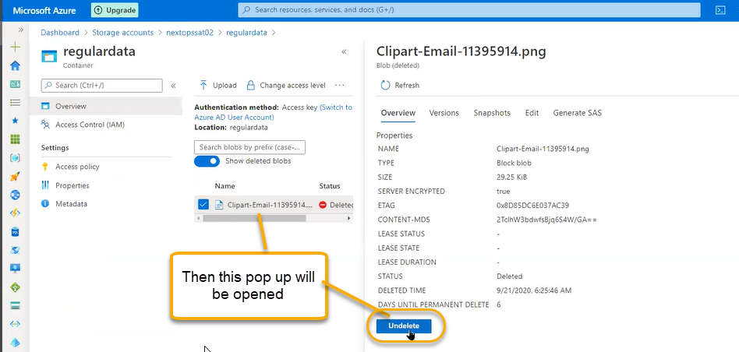

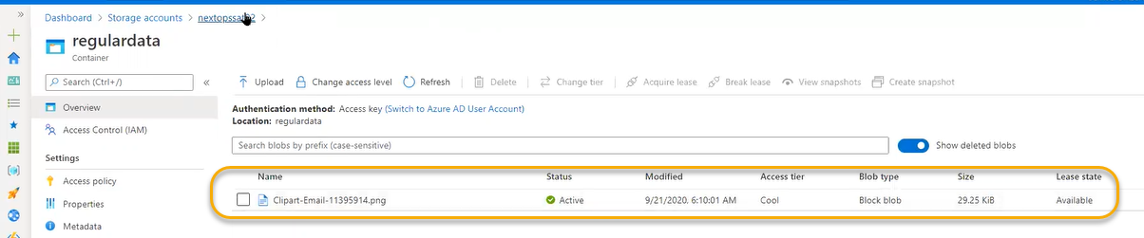

Access policy: It is associated with SAS tokens. Storage account can store sensitive matter as non-sensitive matter. Immutable blob storage: while maintain the company data in our company some legal issues is in involved company will be seized during the running of this case we can add the lock for particular account. Tag is nothing but case number

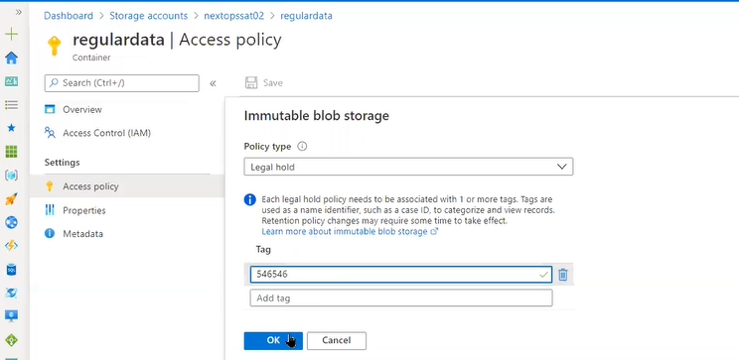

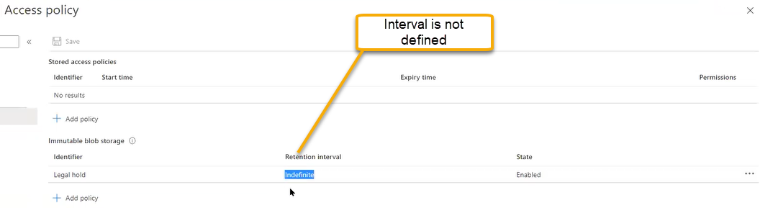

Time Based retention

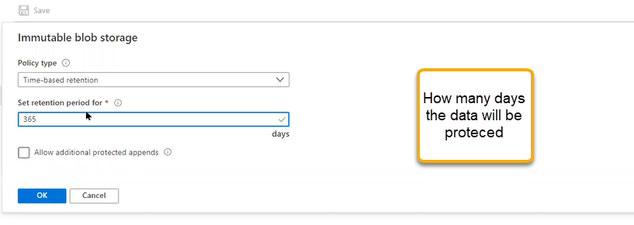

Stored access policy

In the regular data we have content and files and generating SAS tokens for each file is not a best practice to avoid the process we can use stored access policy

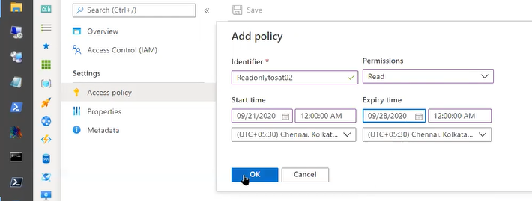

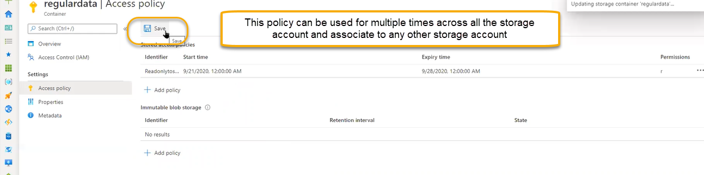

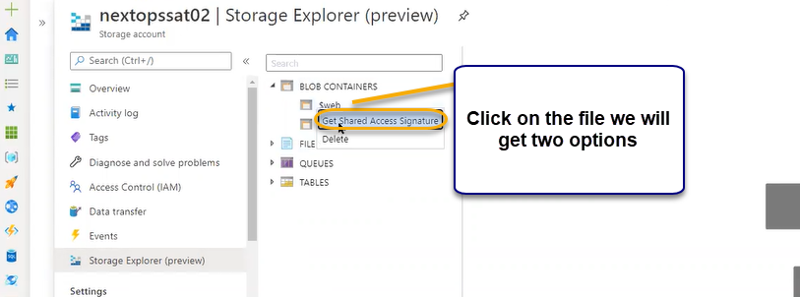

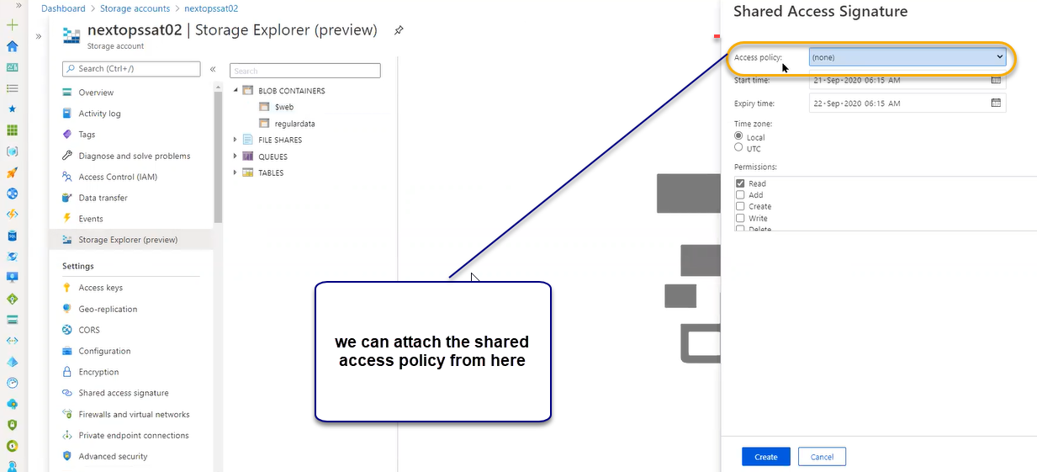

And click on create

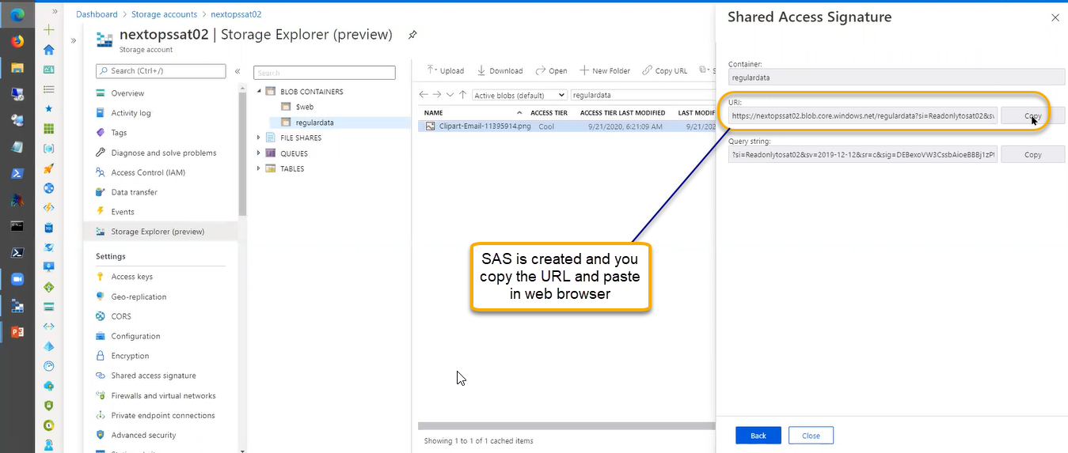

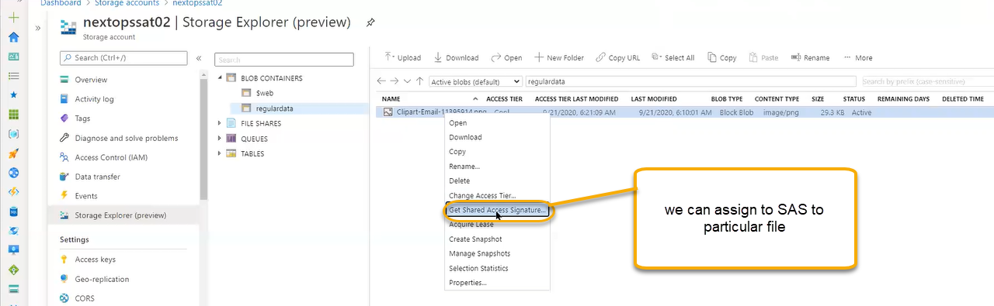

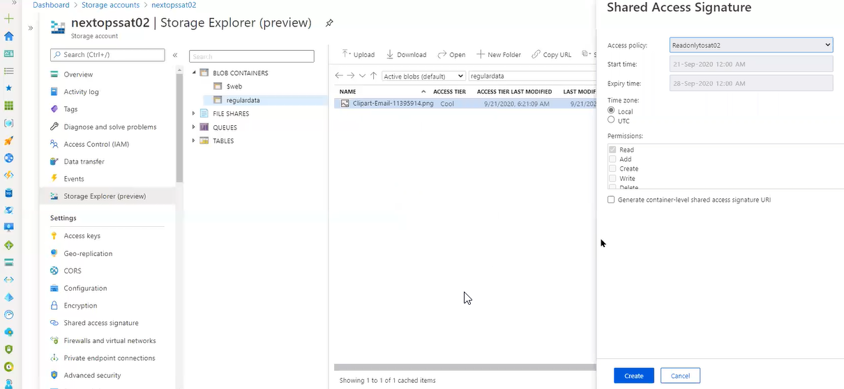

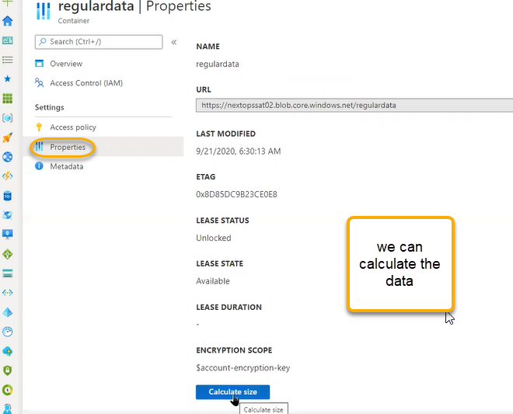

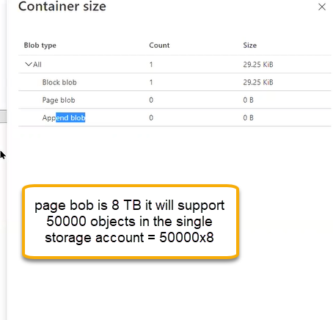

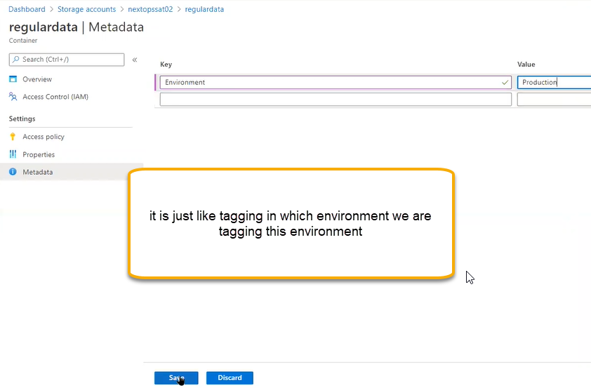

Custom Domain: if any website/URL is registered in domain register and if you want to use the domain in that storage account, we can map here

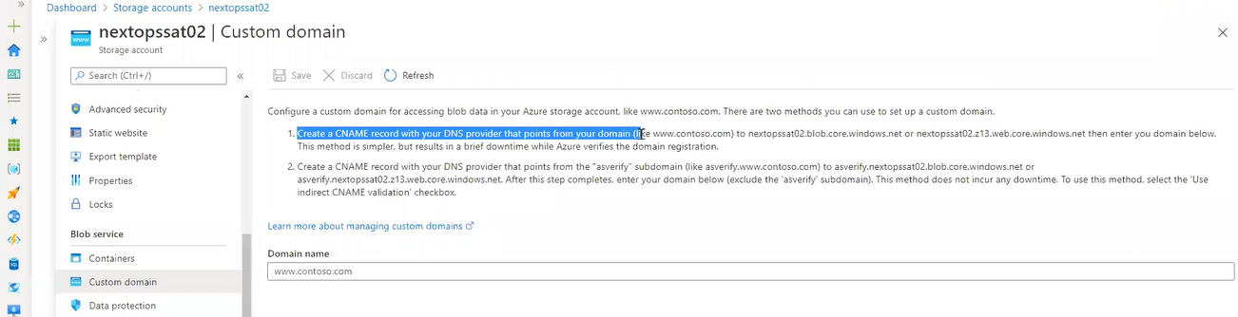

If you see the static website the URL is autogenerated and we cannot give outside

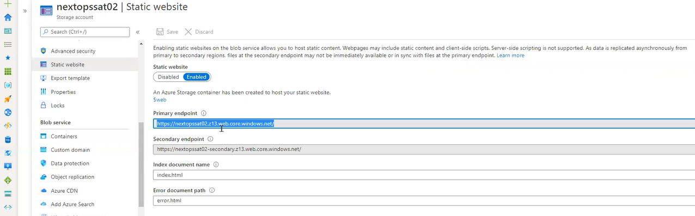

Every domain we registered they will give DNS. In the active directory we need to map the domains

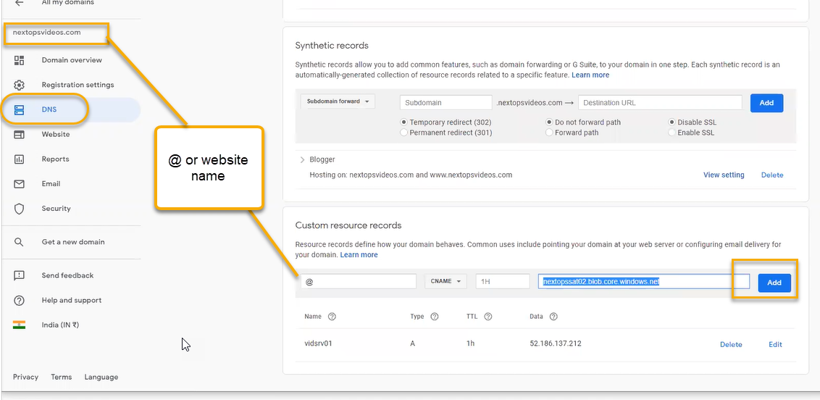

It will verify the data and we need to save it

Data protection :

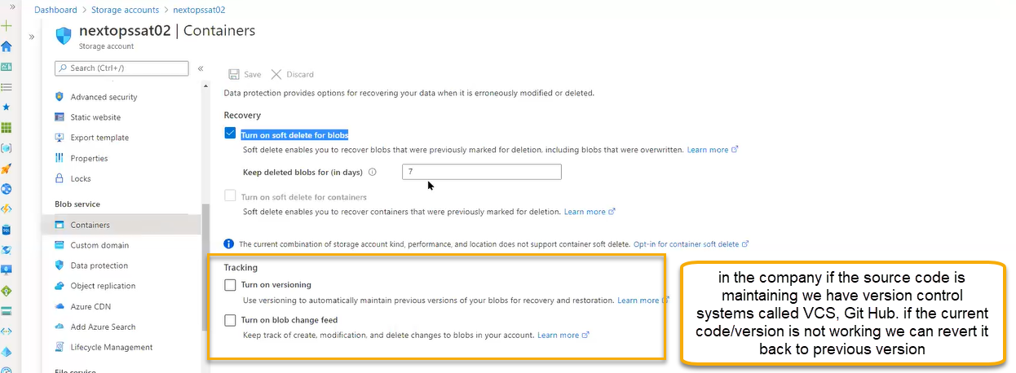

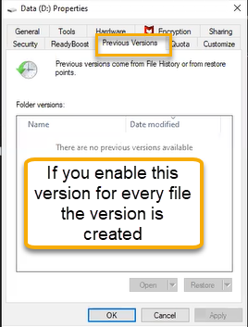

For any one of the company ransomware attack is happened so completely active directory company data, file shares is encrypted for decrypting the ransomware attack we need code they will ask the amount in that cases we can do versioning in windows computer

If you turn on the versioning the then the versioning’s will be createdand if you Turn on the blobs change feed all updates we can see changes like updates

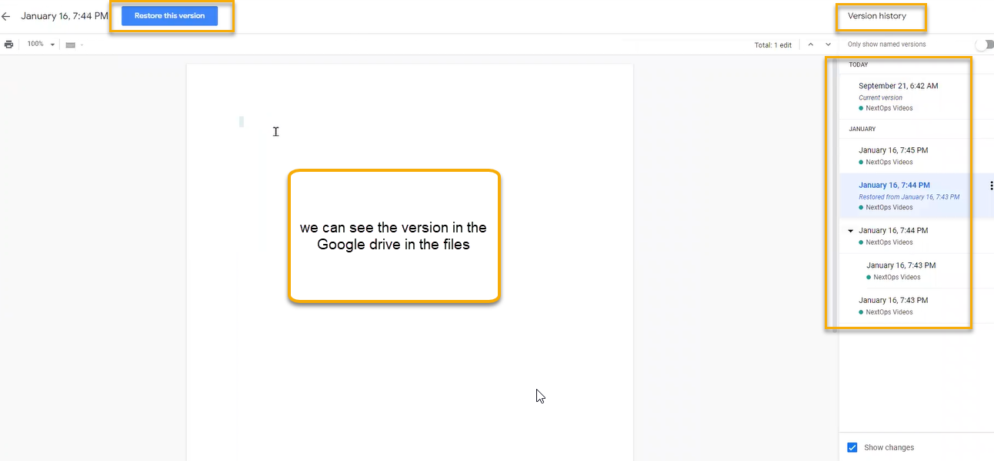

Object replication

If you want to replicate our storage account in another storage account with in/ without subscriptionfor that we need to enable the versioning while creating the storage account

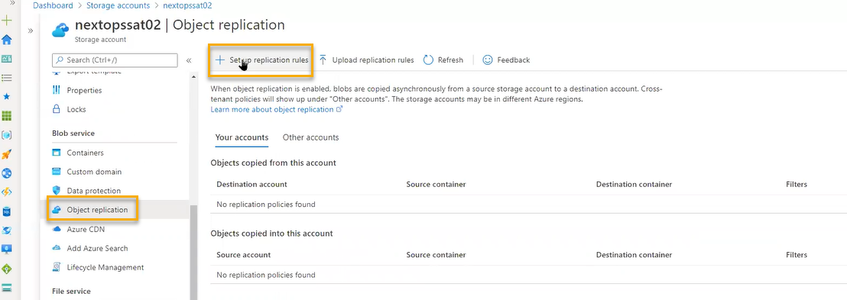

We can select bobs, files or anything

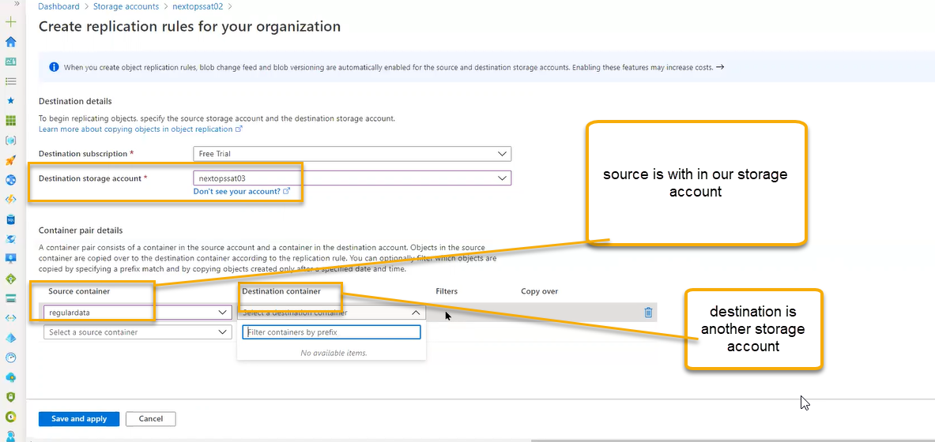

Azure CDN

If any one of the storages is back ending the browsers like YouTube where high bandwidth is required in which storage account does not support

In these cases, we will set up POP (Point of Presence)

If am accessing the you tube first time it will reach to POP and then pop to it reaches to server

If second person accessing the YouTube, then in the POP (Cache will stored) with that cache it will browse you tube

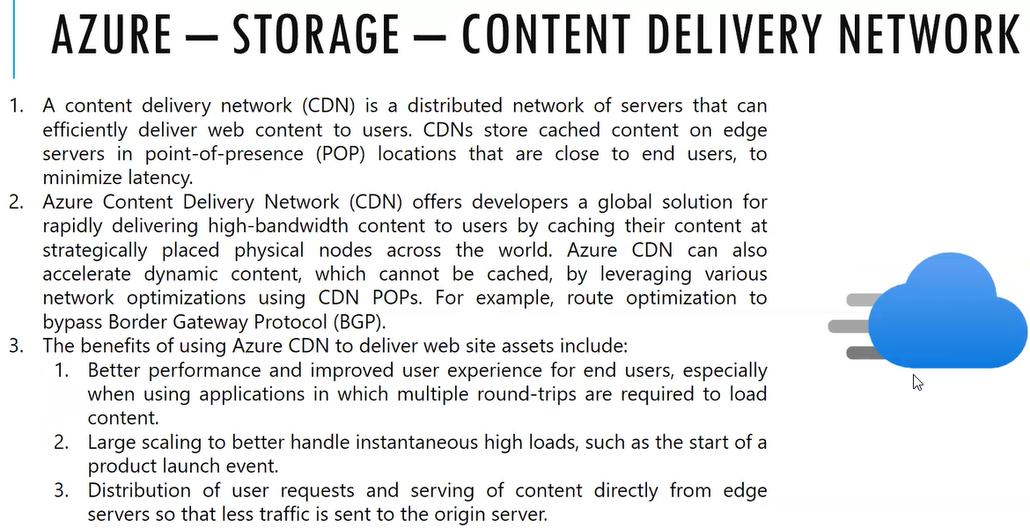

We need to create the CDN and associate to storage delivery

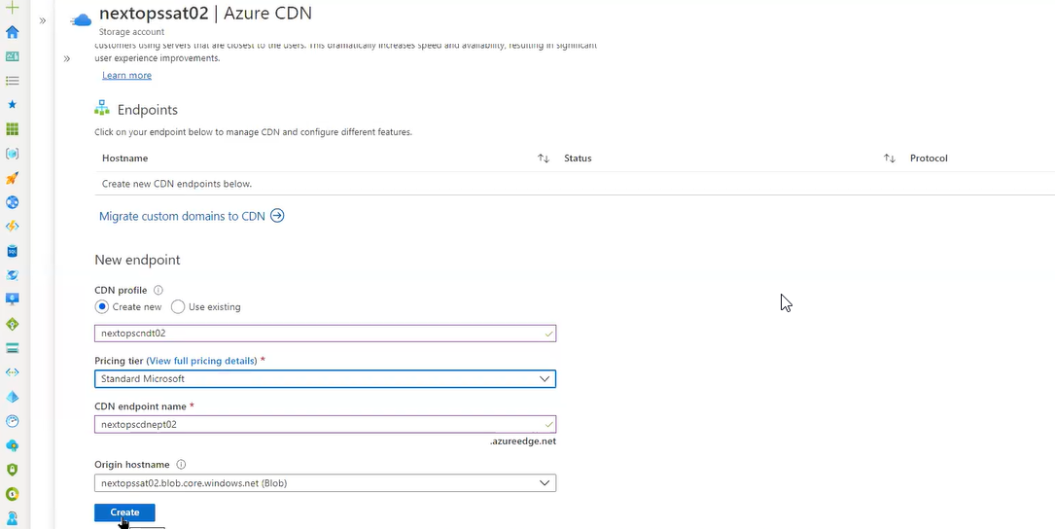

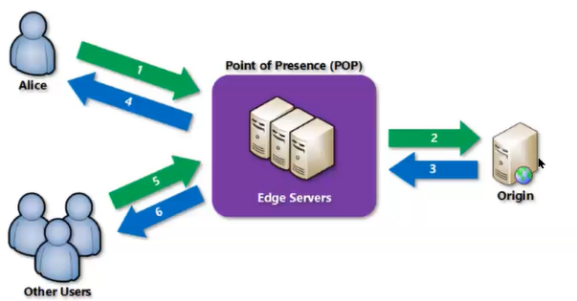

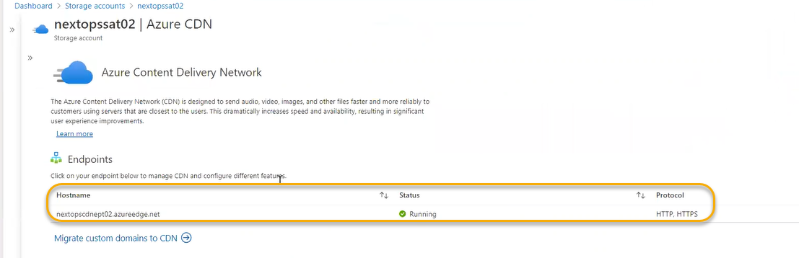

If you enable the CDN the performance will be improved

